Bishal Dahal — WP3 Individual Contribution & Progress Report
PRT661 – Data Science Practice | Dan6 Theme 2 | Modelling, Forecasting and Verification
Student | ID | WP3 role | Workstream
Bishal Dahal | S388095 | Verification & Dashboard Lead | Feature safety · seasonal-naive baselines · metrics · skill against naive · actual verification

Evidence note This document is aligned to the verified 14 September Stage 3 run. Contribution descriptions preserve the role boundaries in the existing WP3 documents and describe shared integration as team work rather than assigning the final pipeline to one person.

1. Allocated WP3 responsibility
Bishal’s workstream provides the independent measurement layer around the modelling pipeline. Before fitting begins, the feature-safety gate checks that benchmark/context fields cannot enter a model. During model comparison, Bishal’s seasonal-naive baselines establish the minimum performance a complex model must beat. After each historical or 2026 forecast, the same metric definitions are used for MAE, RMSE, sMAPE, Bias and skill against naive. Finally, current September actuals are matched to the frozen forecast for independent verification.
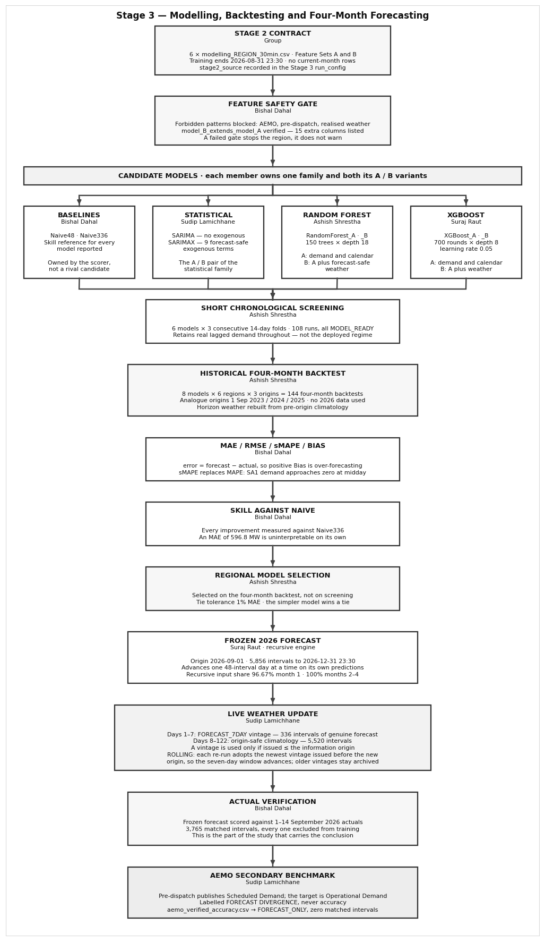
Figure 1. Bishal-owned blocks in the final WP3 architecture: feature-safety gate, seasonal baselines, metrics, skill-against-naive and actual verification.

2. Feature-safety gate
The feature gate exists because a forecasting model can produce an impressive score while using information it would never possess in real operation. The final audit checks Feature Set A and B, direct weather placement, weather provenance, the Stage 2 horizon report and the strict previous-month cutoff before any candidate is accepted.
Check group | Verified outcome
Feature Set A | 39 features; no unsafe columns.
Feature Set B | 54 features; no unsafe columns.
Direct weather in Model A | None.
Model B weather provenance | Six direct weather fields covered by provenance.
Stage 2 forecast-weather validation | No FAIL rows.
Previous-month cutoff | Declared 31 Aug 2026 23:30; prediction starts 1 Sep 2026.

Why this is independent verification A model-family owner does not get to decide that their own inputs are safe. The safety gate runs before the candidate comparison and can stop the pipeline rather than merely writing a warning.

3. Seasonal-naive baselines
Naive48 repeats the same half-hour from the previous day; Naive336 repeats the same half-hour from the previous week. Both are recursive over the four-month horizon, so once their lag points beyond the origin they consume their own earlier predictions instead of later actual demand. These baselines answer a simple but essential question: does the ML/statistical complexity perform better than assuming demand repeats its recent seasonal pattern?
Baseline | Meaning | Use in WP3
Naive48 | Yesterday, same half-hour | Strong daily-pattern benchmark.
Naive336 | Previous week, same half-hour | Strong weekly-pattern benchmark and primary skill reference when it is the lower-MAE naive.

4. Metrics and skill interpretation
Metric | Non-technical meaning | WP3 interpretation
MAE | Average size of the miss | Primary regional selection metric in MW.
RMSE | Penalises occasional large misses | Shows whether a model has severe errors hidden by average MAE.
sMAPE | Scale-aware percentage error | Preferred to ordinary MAPE where SA1 demand approaches zero.
Bias = forecast − actual | Systematic direction of error | Positive = over-forecast; negative = under-forecast.
Skill vs naive | Percentage MAE improvement over strongest seasonal naive | Positive values show complexity earns its cost.

All six selected models show positive four-month skill against the best seasonal naive, ranging from 26.5% to 34.8%. This is stronger evidence than simply saying Random Forest has the lowest error because it confirms the chosen models beat an interpretable seasonal benchmark.
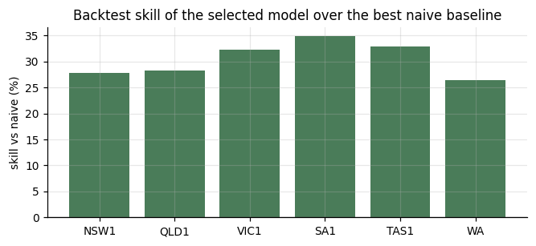
Figure 2. Skill of the selected regional models against the best seasonal-naive baseline. Positive values mean lower MAE than the baseline.

5. Independent September 2026 verification
Region | Intervals | MAE | RMSE | sMAPE | Bias | MedAE
NSW1 | 625 | 401.2 | 495.4 | 6.27% | +227.3 | 346.5
QLD1 | 625 | 184.3 | 286.7 | 3.91% | +44.1 | 95.5
SA1 | 625 | 154.0 | 234.0 | 19.31% | -1.1 | 86.5
TAS1 | 625 | 44.6 | 56.8 | 4.40% | -4.1 | 36.6
VIC1 | 625 | 332.2 | 416.7 | 6.84% | -93.2 | 298.2
WA | 640 | 129.5 | 177.4 | 6.78% | -23.1 | 94.4

The frozen forecast was matched to 3,765 actual half-hour intervals from 1–14 September 2026. These actuals were kept in a separate Stage 2 verification file and never entered training. Pooled MAE is 207.3 MW, pooled RMSE 313.3 MW and pooled sMAPE 7.91%.
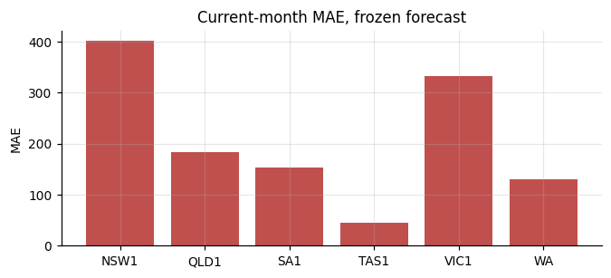
Figure 3. September 2026 MAE by region for the frozen forecast. The chart is verification evidence, not training feedback.

6. Integrity findings
Suite | Result | Interpretation
Feature safety | 8/8 PASS | Feature contracts and cutoff are safe.
Leakage tests | 78/78 PASS | No detected future-actual leakage; recursive lag provenance is consistent.
Forecast integrity | 110 PASS / 10 WARNING | No NaN/Inf/duplicate/frequency failures; NEM interval-label convention remains a visible warning.
ZIP artefact verification | 41/41 PASS | Required output files survive final packaging.

7. Team collaboration and handoff
- Ashish supplies candidate backtests and selection outputs; Bishal applies the same metric rules rather than refitting or changing them.
- Sudip’s AEMO/source classifications constrain what Bishal may call “accuracy”; Scheduled Demand comparisons remain divergence/consistency evidence.
- Suraj supplies recursive lag provenance so Bishal can distinguish early history-supported predictions from later self-recursive forecasts.
- The group reviews warnings rather than suppressing them for a cleaner result.

8. Code and evidence artefacts
Artefact | Contribution evidence
01_Bishal_Dahal_Baselines_Metrics_Verification.py | Feature gate, Naive48/Naive336, metric definitions, skill calculation, exact-timestamp verification and integrity checks.
validation/feature_safety_audit.csv | Eight pre-modelling safety checks.
validation/current_month_verification_summary.csv | Independent September regional metrics.
validation/leakage_tests.csv | 78 explicit leakage checks.
validation/forecast_integrity_checks.csv | Structural acceptance/warning evidence.

9. Professional reflection
WP3 showed that verification is not a final cosmetic step. The naive baselines make sure complex models earn their complexity, Bias exposes systematic direction that MAE can hide, and the integrity suite exposes a timestamp-labelling warning even though the numerical forecast still looks plausible. The next verification layer should add uncertainty and continued month-by-month monitoring so the dashboard communicates both expected demand and how much confidence users should place in it.

